October 1st, 2008

TACA AIRLINES NEW IMAGE

TACA Airlines (American Continent Air Transport) unveiled the evening of last September 24th the new logo and corporate image in a unprecedented extravaganza event at the El Salvador International Airport. The renovation came after two and a half years of studies. During the event, Roberto Kriete, CEO said: “In TACA we are starting an integral transformation”. Estuardo Ortiz, the Commercial Vice President explained that the new image was developed by the TACA Airlines Marketing Department and with the assistance of New York based consultant company Lippincott. New uniforms designed by famous Colombian designer Isabel Henao were also shown that evening. TACA Airlines operates from eight cities in the U.S. and Toronto, Canada to Central and South America. One of the most modern fleet in the Americas made up of 38 aircraft, Airbus A-319/320/321 and two new Brazilian made Embraer E-190.TACA Airlines new image, part of the company plans to become the preferred carrier to Latin America. You will be getting more information in the next days of our changes.

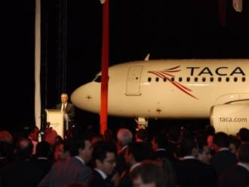

DISTRIBUTION/RESERVATIONS POLICIES

Several weeks ago TACA Airlines” Leisure Department sent you via email the new “Distribution Policy” that includes information of non cancelled segments, duplicates, churning, passive segments, fake names and fake tickets. If you are experiencing PNR cancelations that not apply to the practices mentioned, please contact your Leisure Account Executive. If you have not received the policy please let us know.

IT CODE

It is very important that all Hybrid Agencies include the assigned IT code correctly in the Tour Code Box of the TACA Airlines tickets. This is the only way that we can measure the performance of the agency. Failure of including the IT code can determine keeping a leisure contract for an agency. Please remember that IT codes must be included when selling a TACA Airlines (TA or LR) ticket in conjunction with a land package and using any type of fare (Bulk Leisure Fares both fixed or CAT 25) or Published Fares. If you have any questions please contact your leisure account executive.

TACA AIRLINES BINDER

We have created for you a complete “Quick Reference Binder” that includes information about our Bulk Leisure Fares (fixed and CAT 25), Off-Line Bulks TACA Airlines/United Airlines, Rules and Guidelines, Fleet information, Hubs and Route System. These binders are excellent way for your agents to keep all information centralized. Please contact your leisure account executive and let them know how many binders you would need for your operational personnel.

NEXT DESTINATION: PARAGUAY

Effective December 15th, TACA Airlines starts services between the Lima hub and Asuncion, capital of Paraguay. One of the most beautiful countries in Latin America, it is also commercial hub in the region. The famous Ypacarai Lake (made famous by a romantic ballad) is one of the natural wonders of the region. We invite you to now sell Paraguay with the excellent service of TACA Airlines from the United States via Lima.

TACA Trivia

TACA Airlines recently received the first Brazilian regional jet that will be operating flights from the Costa Rica hub. Who is the maker of this modern jet?

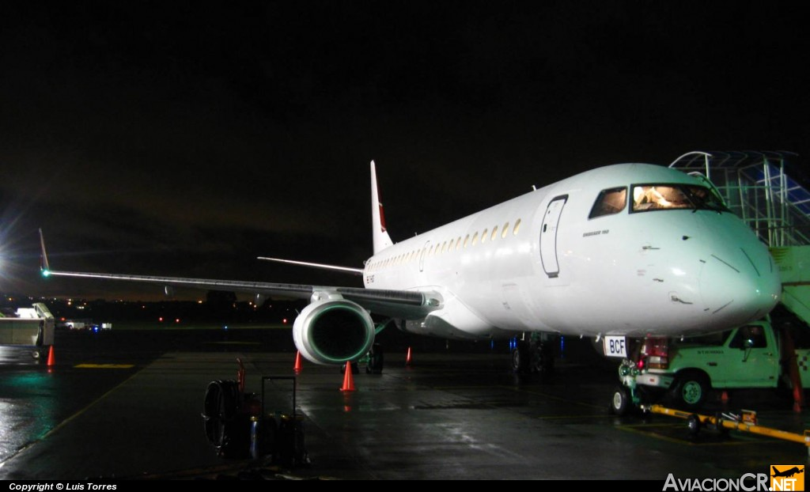

Response: Embraer, the company that constructs the ultra modern Embraer E-190. The new TACA Airlines jet.

