

Wholesaler & Leisure Sales Department
October 1st, 2009

FLIGHTS TO ROATAN ISLAND

Effective November 15th TACA Airlines introduces daily non-stop flights between San Salvador and Roatan Island operated with modern ATR-42 aircraft. Now you will be able to sell Roatan from San Francisco, Los Angeles, Houston, New York-JFK, Washington D.C. , Chicago and Orlando with excellent connections in our “super hub” Comalapa International Airport in San Salvador.

Flight # | Origin/Destination | Departure | Arrival | Frequency
TA-216 | SAL-RTB | 9:00 | 10:30 | DAILY
TA-217 | RTB-SAL | 17:00 | 18:30 | DAILY

Also during the high season TACA Airlines will operate the non-stop jet services from Miami and Houston with the following schedules:

Operating from December 6th 2009 until January 10th 2010.
Flight # | Origin/Destination | Departure | Arrival | Frequency
TA-380 | RTB-MIA | 10:17 | 13:22 | SUN
TA-381 | MIA-RTB | 15:22 | 16:32 | SUN

Operating from December 5th 2009 until January 16th 2010.
Flight # | Origin/Destination | Departure | Arrival | Frequency
TA-430 | RTB-HOU | 10:09 | 12:57 | SAT
TA-431 | HOU-RTB | 14:12 | 16:47 | SAT

Roatan Island is one of the most popular destinations in the Caribbean. The second biggest barrier reef in the world can be found around the Bay Islands.

IMPORTANCE OF THE IT CODE*

(*)This only applies for HYBRID AGENCIES

It is very important that all Hybrid Agencies include the assigned IT code correctly in the Tour Code Box of the TACA Airlines (TA & LR) tickets. This is the only way that we can measure the performance of your agency. Failure of including the IT code can determine keeping a leisure contract for an agency. Please remember that IT codes must be included when selling a TACA Airlines ticket in conjunction with a land package and using any type of fare (Bulk Leisure Fares both fixed or CAT 25) or Published Fares. If you have any questions please contact your leisure account executive. Assigned IT codes do not change and must always appear correctly in the TOUR CODE BOX of the tickets.

A NEW GATEWAY FROM NORTH AMERICA: ORLANDO

Effective November 1st, TACA Airlines introduces tri-weekly flights from Orlando, Florida to El Salvador and connections to Belize City, Guatemala City, Managua, San Jose, Tegucigalpa, San Pedro-Sula and Roatan Island*. Flights will be operated with the ultra modern Embraer-190 that features individual screens in every seat. Flights already in the GDS.

Flight # | Origin/Destination | Departure | Arrival | Frequency
TA-423 | MCO-SAL | 6:00 | 7:45 | MON-THR-SAT
TA-422 | SAL-MCO | 19:20 | 23:05 | WED-FRI-SUN
(*) Orlando-San Salvador-Roatan effective November 16th.

TACA TRIVIA

Which is the biggest airplane of the TACA Airlines fleet?

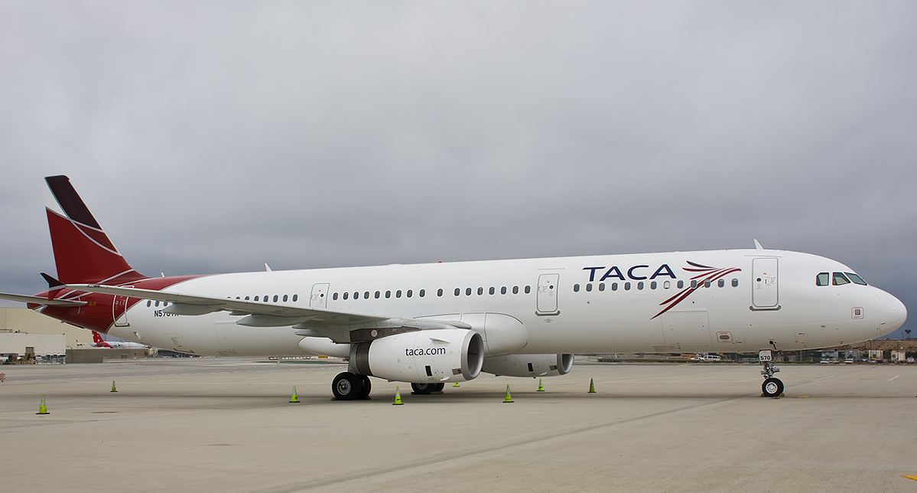

Answer: The Airbus A-321
Length: 43.69 m
Diameter: 3.95 m
Fuel Capacity: 7,051 Gls
Passenger Capacity: 194 (12C – 182Y)
NEW SCHEDULE FROM HOUSTON

Effective November 16th TACA Airlines introduces a new schedule from Houston International Airport. The flight will be non-stop from Houston to San Salvador with immediate connections to Guatemala, Belize, Roatan Island, Honduras, Nicaragua and Costa Rica.

Flight # | Origin/Destination | Departure | Arrival | Frequency
TA-420 | SAL-HOU | 19:35 | 22:35 | DAILY
TA-421 | HOU-SAL | 4:30 | 7:30 | DAILY

NEW TACA AIRLINES ROUTES

TACA Airlines is opening new services next month. New flights include: Orlando-San Salvador, San Jose-San Salvador-Cancun, San Salvador-Roatan Island, Lima-Mexico City and Lima-Porto Alegre, Brazil. All flights are available to sell in your GDS.

DIFFERENCE BETWEEN TACA FARES FROM USA TO CENTRAL & SOUTH AMERICA (Individual Passengers)

Published Fares
- After reservation is made, ticketing must be done 24 hours after, otherwise our system will automatically cancel the PNR.
- Most of published fares do not have an ADVANCE PURCHASE.
- Reservation MUST have a stored fare.
- PLATINUM, GOLD and SILVER status agencies have access to an UPFRONT COMMISSION. BRONZE agencies do not have commission on published fares.

Bulk Fixed Fares
- Before ending the transaction, include the OSI: OSI YY WHOLESALER in order to obtain a time limit of 21 days prior the departure.
- All Bulk Fixed Fares have an Advance Purchase of 14 days prior departure.
- Reservation MUST have a stored fare.
- Bulk Fixed Fares are NETS, non commissionable.

Bulk CAT 25 Fluctuating Fares
- Before ending the transaction, include the OSI: OSI YY WHOLESALER in order to obtain a time limit of 21 days prior the departure.
- All CAT 25 Fluctuating Fares have an Advance Purchase of 14 days prior departure.
- Reservation MUST have a stored fare.
- Bulk CAT 25 Fares are NETS, non commissionable.

(*) Different OSI segment for Student Agencies.

