

Wholesaler & Leisure Sales Department
September 1st, 2009

A NEW GATEWAY FROM NORTH AMERICA: ORLANDO

Effective November 1st, TACA Airlines introduces tri-weekly flights from Orlando, Florida to El Salvador and connections to Belize City, Guatemala City, Managua, San Jose, Tegucigalpa, San Pedro-Sula and Roatan Island*. Flights will be operated with the ultra modern Embraer-190 that features individual screens in every seat. Flights already in the GDS.

Flight # | Origin/Destination | Departure | Arrival | Frequency
TA-423 | MCO-SAL | 6:00 | 7:45 | MON-THR-SAT
TA-422 | SAL-MCO | 19:20 | 23:05 | WED-FRI-SUN
(*) Orlando-San Salvador-Roatan effective November 16th.

DAILY FLIGHTS TO ROATAN

Effective November 15th TACA Airlines introduces daily non-stop flights between San Salvador and Roatan Island operated with modern ATR-42 aircraft. Now you will be able to sell Roatan from San Francisco, Los Angeles, Houston, New York-JFK, Washington D.C. , Chicago and Orlando with excellent connections in our “super hub” Comalapa International Airport in San Salvador.

Flight # | Origin/Destination | Departure | Arrival | Frequency
TA-216 | SAL-RTB | 9:00 | 10:30 | DAILY
TA-217 | RTB-SAL | 17:00 | 18:30 | DAILY

Roatan Island is one of the most popular destinations in the Caribbean. The second biggest barrier reef in the world can be found around the Bay Islands.

NEW FLIGHT FROM LIMA TO CUZCO

TACA Airlines will offer a new flight from Lima to Cuzco effective August 15th, 2009. Flight is already in the GDS open for sale.

Flight # | Origin/Destination | Departure | Arrival |  | Frequency
TA-009 | LIM-CUZ | 10:10 |  | 11:30 | Daily
TA-008 | CUZ-LIM | 12:10 |  | 13:30 | Daily

IT CODE*

(*)This only applies for HYBRID AGENCIES

It is very important that all Hybrid Agencies include the assigned IT code correctly in the Tour Code Box of the TACA Airlines (TA & LR) tickets. This is the only way that we can measure the performance of your agency. Failure of including the IT code can determine keeping a leisure contract for an agency. Please remember that IT codes must be included when selling a TACA Airlines ticket in conjunction with a land package and using any type of fare (Bulk Leisure Fares both fixed or CAT 25) or Published Fares. If you have any questions please contact your leisure account executive. Assigned IT codes do not change and must always appear correctly in the TOUR CODE BOX of the tickets.

CHANGES IN COMMISSIONS

For all PLATINUM/GOLD and SILVER Level Wholesalers there has been some changes in the “Published Fare Commissions”. Commission does not apply for published fares within Central and South America nor published fares from Latin America to the U.S. and Canada. For more information contact your Leisure Account Executive.

NEW EMAIL FOR GROUP REQUESTS

We have a new email address for the Group Desk in El Salvador. Please address all group requests to the following address: group.desk@taca.com. You can address the emails to Renee Rodriguez or Erick Guerra. Always advise them you are a Leisure Wholesaler and please copy your Leisure Account Executive.

EXPRESS CHECK-IN

Advise your clients to check-in and get their boarding pass 24 hours before departure in www.taca.com and that way avoid cues at the Airport Check-in counters. Another service of the new TACA Airlines.

TACA TRIVIA

Which are the airlines that code-share with TACA Airlines?

Answer: United Airlines, Iberia Airlines, Lufthansa, Cubana Airlines, Avianca and Aerosur.

CONTACTS OF THE LEISURE SALES DEPARTMENT

For more information please contact your Leisure Account Executive: Dana Ullmann or Zeida Lobato.

Dana Ullmann. Email: dana.ullmann@taca.com / Phone: (917) 699-6085

Zeida Lobato. Email: Zeida.lobato@taca.com / Phone: (305) 725-6835
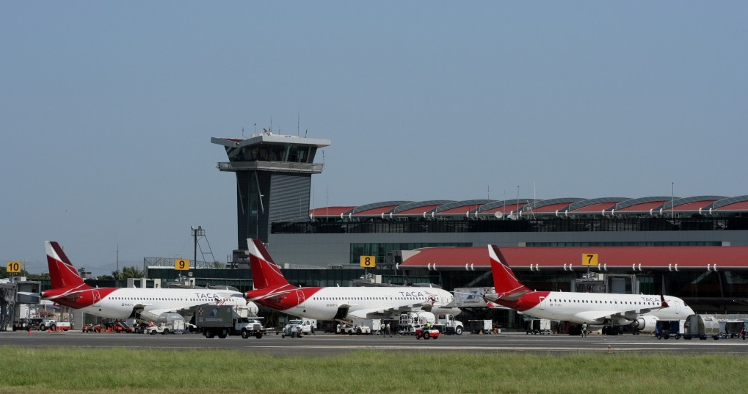

TACA Airlines Hub at Juan Santamaria International Airport in San Jose, Costa Rica.

