

Wholesaler & leisure sales department newsletter
February 01st, 2010

AVIANCA-TACA joint venture ready for implementation
Avianca Airlines and TACA Airlines have formally completed a landmark deal which will result in 13 carriers from 10 Latin American countries becoming part of one airline holding company.

The two airline groups announced February 1st, they have secured all the regulatory and antitrust approvals required to establish a new parent company, completing the process which began when their “strategic merger” was announced in October 2009. As a result both airlines can now formally establish the new Bahamas-based parent company and begin the process of strategically integrating the two companies.

Going into Avianca-TACA will be all three of the Colombian carriers currently under the Avianca structure (Avianca, SAM and Tampa Cargo) Synergy’s stake in Brazil’s Ocean Air and Ecuador’s Aero Gal will also transfer to the new parent company. On the TACA side 100% of the shares in El Salvador-based TACA International will transfer over to the new parent company. Also moving over to Avianca-TACA are the shares TACA Airlines now has in seven much smaller carriers: TACA Peru, Costa Rica’s LACSA and SANSA Regional, Guatemala’s AVIATECA, Nicaragua’s NICA and La Costeña, Panama’s Aeroperlas Regional and Honduras’ Isleña. The airlines SANSA, Aviateca, La Costeña, Aeroperlas and La Costeña operate turboprops under the TACA Regional brand.

Avianca-TACA will have the largest network in Latin America, serving 75 cities in the region and more than 100 cities globally. The airlines combined will generate about $3 billion in annual revenues, making the Avianca-TACA the fourth largest airline group in Latin America. Combined the two airlines will operate 129 aircraft and have almost 12,000 employees.

The importance of the IT code*
(*)This only applies for hybrid agencies
It is very important that all Hybrid Agencies include the assigned IT code correctly in the Tour Code Box of the TACA Airlines (TA & LR) tickets. This is the only way that we can measure the performance of your agency. Failure of including the IT code can determine keeping a leisure contract for an agency. Please remember that IT codes must be included when selling a TACA Airlines ticket in conjunction with a land package and using any type of fare (Bulk Leisure Fares both fixed or CAT 25) or Published Fares. Assigned IT codes do not change and must always appear correctly in the TOUR CODE BOX of the tickets.

Emergency situation in Cuzco
As you may know by now, bad weather has affected flights to and from Cuzco, Peru. For all information of protection of passengers, re-routings, refunds, etc. please contact TACA Airlines reservation centers in the United States and Canada for details and instructions. The numbers are:
- United States: 1-800-400-8222.
- Canada: 1-800-722-8222.

Code sharing with US Airways
Effective January 11th 2010 TACA Airlines and Phoenix based US Airways (US) have started the code sharing flights from Philadelphia, Phoenix, Las Vegas, New Jersey, Minneapolis, Buffalo, Nashville and Indianapolis to Central and South America. Cities include: Guatemala, Belize, El Salvador, Honduras, Nicaragua, Costa Rica and Peru.

Future enhancements to the relation of both air carriers include possibility to ear miles in both “Frequent Flyer Programs”.

Support from account executives
Please be advised Dana Ullmann will be in a “leave of absence” until April 27th, 2010. For any assistance please contact:
- Zeida Lobato: zeida.lobato@taca.com
- Glenn Heilbron: gheilbron@taca.com

Trivia
Which is the biggest airliner of the TACA Airlines fleet?

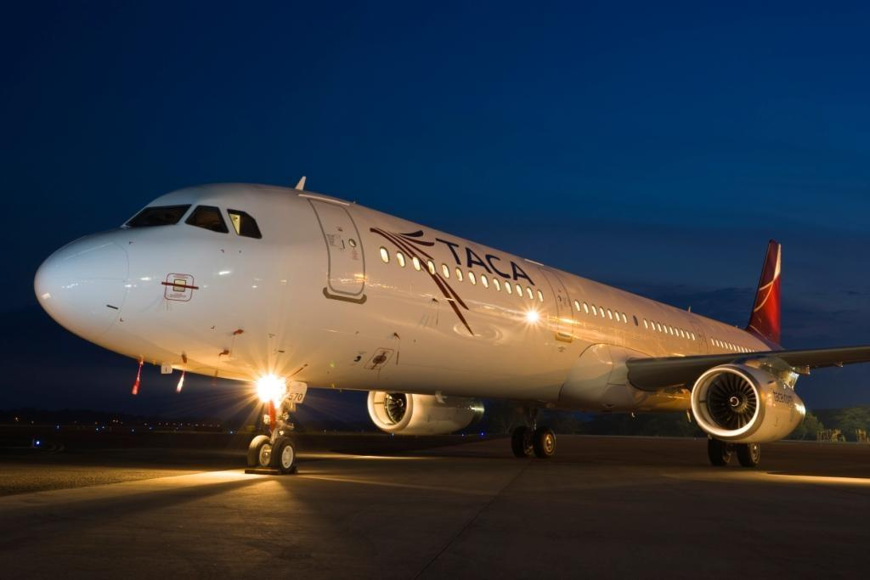
Answer: The Airbus A-321
- Length: 43.69 meters
- Diameter: 3.95 meters
- Fuel Capacity: 7,051 US Gls.
- Passenger Capacity: 194

