
IAD to LIM

Special override total commission – 12%

COSTAMAR TRAVEL

05580761, 10527930, 10606400, 10679222, 14527096, 31503964, 31507556, 31507626, 31509483, 31526703, 31529035, 31534720, 31541182, 31541451, 31544682, 31546406, 31556195, 31596655, 3161319, 31614262, 31618005, 31619055, 31697503, 33535154, 33535714, 33601142, 33627742, 33628383, 33756166, 33960430, 34531976, 39501523, 49596201, 45548926, 44770876

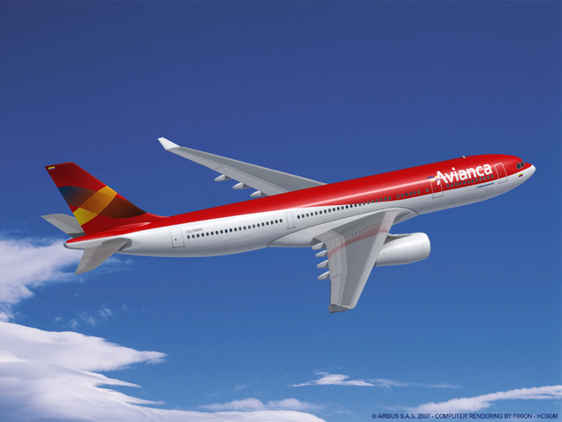

CONDITIONS:
- ORIGIN: must be between JUNE 13 and AUGUST 13, 2008
- ISSUANCE: must be between MAY 19 and JUNE 30, 2008
- TRAVEL MUST ORIGINATE IN USA
- TRAVEL TO/FROM USA MUST BE ON AV286/AV287

