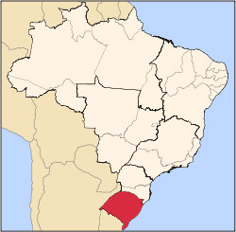


Effective December 1st 2009 TACA Airlines will start services to destination #42. From the hub at Lima’s Jorge Chaves International Airport non-stop service to Porto Alegre, the capital of the State of Rio Grande do Sul.
Flights from the United States, Central America and the Caribbean will connect in Lima to Porto Alegre.
This will be the third TACA Airlines Brazilian destination in addition to Sao Paulo and Rio de Janeiro.

Flight # | Origin/Destination | Departure | Arrival | Frequency
TA-088 | LIM-POA | 21:45 | 5:35 +1 | MON-WED-FRI
TA-089 | POA-LIM | 7:55 | 9:45 | TUE-THR-SAT

Porto Alegre is a great industrial and agricultural center in the south of Brazil.
In Rio Grande do Sul you can also find the most southern city of the country, Chuí, on the border with Uruguay. The mountain region, where winter can be rigorous, has cities with European characteristics, such as Gramado and Canela. In the region of Bento Gonçalves and Caxias do Sul, the largest wine producing center of Brazil, the attraction is Italian gastronomy. Besides the European influence, the gaúcho, or inhabitants of Rio Grande do Sul, cultivates the traditions of the Pampas — region of the border with Uruguay and Argentina — such as drinking mate tea, known as chimarrão, eating the typical barbecue or churrasco and wearing bombachas (baggy trousers), boots and large hats.

Fly to Porto Alegre on TACA Airlines. Flights now in the GDS.

